Hw3 Horn & Schunck OpticalFlow

R07941023 呂彥穎 光電所一年級

Method

1. Create the frame 2 from frame 1

Frame1 (original frame)

Frame2 (shift one pixel to the right and downward)

Frame1 Frame2

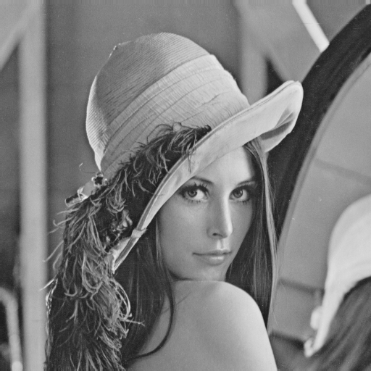



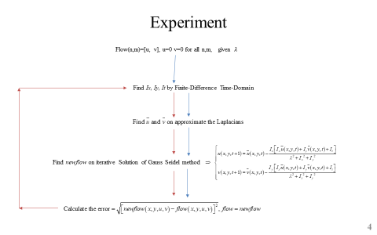

The parameter:







Result:

=0.1

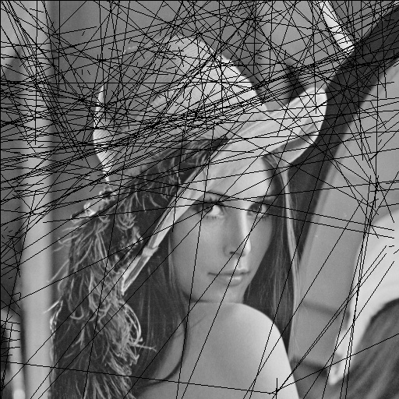

=1

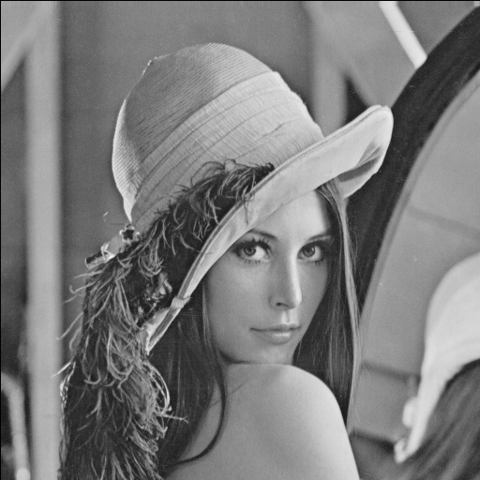

=10



Validation:

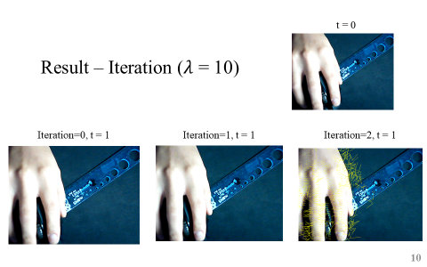

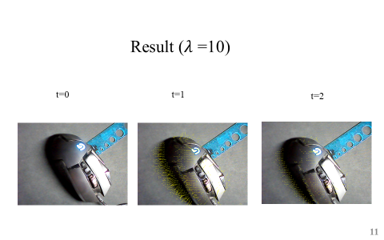

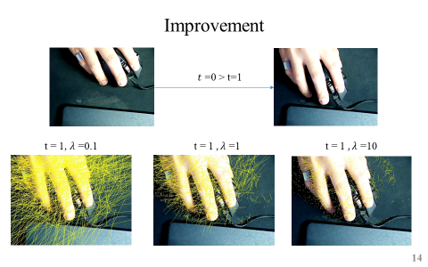

Code (python3)

import numpy as np  
import cv2  
import time  
  
def image(img1, img2):  
 step = 10  
  
 # Detect the image (gray or not)  
 try:  
 prevgray = cv2.cvtColor(img1, cv2.COLOR_BGR2GRAY)  
 gray = cv2.cvtColor(img2, cv2.COLOR_BGR2GRAY)  
 except:  
 prevgray = img1  
 gray = img2  
  
 # https://docs.opencv.org/2.4/modules/video/doc/motion_analysis_and_object_tracking.html  
 ti = time.time()  
 # flow = cv2.calcOpticalFlowFarneback(prevgray, gray, None, 0.5, 3, 15, 3, 5, 1.2, 0) # Gunnar Farneback  
 flow = CalcOpticalFlowHS(prevgray, gray, flow_lambda=0.1, iteration_error=1e-2, convergence_limit=10)  
 tf = time.time()  
 print('t = ', tf - ti, )  
 # Draw line  
 img = gray.copy()  
 h, w = gray.shape[:2]  
 y, x = np.mgrid[step / 2:h:step, step / 2:w:step].reshape(2, -1).astype(int)  
 fx, fy = flow[y, x].T  
 lines = np.vstack([x, y, x + fx, y + fy]).T.reshape(-1, 2, 2)  
 lines = np.int32(lines)  
 line = []  
 for l in lines:  
 if l[0][0]-l[1][0] > 3 or l[0][1]-l[1][1] > 3:  
 line.append(l)  
  
 cv2.polylines(img, line, 0, (0, 255, 255))  
 return img  
  
def CalcOpticalFlowHS(prevgray, gray, flow_lambda, iteration_error, convergence_limit):  
  
 boundary_pandding = 0  
 img_h, img_w = prevgray.shape[:2]  
 pooling_matrix = np.zeros((img_h+1, img_w+1), np.uint8) + boundary_pandding  
 pre_matrix = pooling_matrix.copy()  
 matrix = pooling_matrix.copy()  
 pre_matrix[0:img_h, 0:img_w] = prevgray  
 matrix[0:img_h, 0:img_w] = gray  
 # cv2.imshow('test', pre_matrix)  
 # cv2.waitKey(0)  
  
 flow = np.zeros((img_h, img_w, 2))  
 newflow = np.zeros((img_h, img_w, 2))  
 error = iteration_error*2  
 count = 1  
 while (error > iteration_error):  
 for i in range(img_w):  
 for j in range(img_h):  
 if i > 1 and j > 1 and i < img_w-1 and j < img_h-1:  
 Ex = 1 / 4 * ((int(pre_matrix[j, i+1]) + int(matrix[j, i+1]) + int(pre_matrix[j+1, i+1]) + int(matrix[j+1, i+1])) - (int(pre_matrix[j, i]) + int(matrix[j, i]) + int(pre_matrix[j+1, i]) + int(matrix[j+1, i])))  
 Ey = 1 / 4 * ((int(pre_matrix[j+1, i]) + int(matrix[j+1, i]) + int(pre_matrix[j+1, i+1]) + int(matrix[j+1, i+1])) - (int(pre_matrix[j, i]) + int(matrix[j, i]) + int(pre_matrix[j, i+1]) + int(matrix[j, i+1])))  
 Et = 1 / 4 * ((int(matrix[j, i]) + int(matrix[j+1, i]) + int(matrix[j, i+1]) + int(matrix[j+1, i+1])) - (int(pre_matrix[j, i]) + int(pre_matrix[j+1, i]) + int(pre_matrix[j, i+1]) + int(pre_matrix[j+1, i+1])))  
 u0 = 1/6*(flow[j, i-1][0] + flow[j+1, i][0] + flow[j, i+1][0] + flow[j-1, i][0]) + 1/12*(flow[j-1, i-1][0] + flow[j+1, i+1][0] + flow[j-1, i+1][0] + flow[j+1, i-1][0])  
 v0 = 1/6*(flow[j, i-1][1] + flow[j+1, i][1] + flow[j, i+1][1] + flow[j-1, i][1]) + 1/12*(flow[j-1, i-1][1] + flow[j+1, i+1][1] + flow[j-1, i+1][1] + flow[j+1, i-1][1])  
 u = (u0 - Ex*(Ex*u0+Ey*v0+Et)/(1+flow_lambda*(Ex**2+Ey**2)))  
 v = (v0 - Ey*(Ex*u0+Ey*v0+Et)/(1+flow_lambda*(Ex**2+Ey**2)))  
 newflow[j, i] = [u, v]  
 error = (newflow-flow).reshape(-1)  
 error = np.sqrt(np.sum(np.power(error, 2)))  
 if count > convergence_limit:  
 break  
 flow = newflow  
 print(count, error)  
 count += 1  
  
 return flow  
  
def make_img2(img1, shiftw, shifth):  
 boundary_pooling = 0  
 img_h, img_w = img1.shape[:2]  
 img2 = np.zeros((img_h, img_w), np.uint8) + boundary_pooling  
 img2[shifth:img_h, shiftw:img_w] = img1[0:img_h-shifth, 0:img_w-shiftw]  
 return img2  
  
if __name__ == '__main__':  
 img1 = cv2.imread("lena.bmp", cv2.IMREAD_GRAYSCALE) # gray  
 img2 = make_img2(img1, shiftw=1, shifth=1)  
 Optical_img = image(img1, img2)  
 cv2.imshow('Optical_img', Optical_img)  
 cv2.imwrite('OpticalFlowHS.jpg', Optical_img)  
 cv2.waitKey(0)